Timer program. The program will accept a number of seconds as a command line argument, and steadily count down to 0, decreasing the counter once every second. Echoing should be turned off as the program runs, and should be turned back on once the program exits.

If the user hits Ctrl-C, the timer will pause/unpause. If the user hits Ctrl-\, the program turns echoing back on then terminates.

**Synopsis:**

./st seconds

where seconds is an integer indicating the beginning of the countdown.

**Sample Usages:**

./st 30 causes the timer to count down from 30 to 0

./st prints synopsis

Ctrl-C causes the timer to pause/unpause

Ctrl-\ causes the program to exit gracefully and ensure that echoing is turned back on.

**Sample output**

Here, I let the timer run for about 4 seconds and then hit Ctrl-C to pause the count down so I could get a screen shot. I then hit Ctrl-C again to resume the the count down.

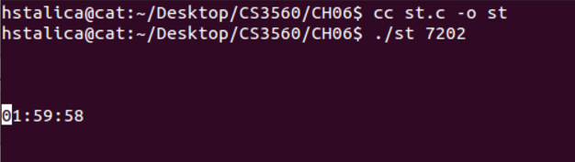

Here, I hit Ctrl-\ to quit the timer.

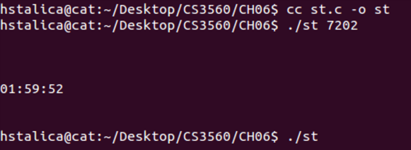

Notice in both samples, you don't see ^C or ^\. That's because echoing was turned off. Also notice after quitting the program, I was able to see stuff I typed on the screen. That's because echoing was turned back on before the program terminated.